
Your summary of benefits


Anthem® Blue Cross and Blue Shield
Your Plan: VANDERBURGH COUNTY: Anthem Blue Access PPO Option 1 with Rx Option T1
Your Network: Blue Access

Visits with Virtual Care-Only Providers | Cost through our mobile app and website
Primary Care, and medical services for urgent/acute care | No charge medical deductible does not apply
Mental Health & Substance Use Disorder Services | No charge medical deductible does not apply
Specialist care | No charge medical deductible does not apply

Covered Medical Benefits | Cost if you use an In-Network Provider | Cost if you use an Out-of-Network Provider
Overall Deductible | $500 person /  $1,000 family | $10,000 person /  $20,000 family
Overall Out-of-Pocket Limit | $1,500 person /  $3,000 family | $15,000 person /  $30,000 family
The family deductible and out-of-pocket limit are embedded, meaning the cost shares of one family member will be applied to the per person deductible and per person out-of-pocket limit; in addition, amounts for all covered family members apply to both the family deductible and family out-of-pocket limit. No one member will pay more than the per person deductible or per person out-of-pocket limit.
All medical and prescription drug deductibles, copayments and coinsurance apply to the out-of-pocket limit.
In-Network and Out-of-Network deductibles and out-of-pocket limit amounts are separate and do not accumulate toward each other.
Doctor Visits (virtual and office) You are encouraged to select a Primary Care Physician (PCP).
Primary Care (PCP) and Mental Health and Substance Use Disorder Services virtual and office | No charge medical deductible does not apply | 30% coinsurance after medical deductible is met
Specialist Provider virtual and office | No charge medical deductible does not apply | 30% coinsurance after medical deductible is met
Other Practitioner Visits
Maternity Doctor services (prenatal/postpartum care and delivery) | 10% coinsurance after medical deductible is met | 30% coinsurance after medical deductible is met
Retail Health Clinic for routine care and treatment of common illnesses; usually found in major pharmacies or retail stores. | No charge medical deductible does not apply | 30% coinsurance after medical deductible is met
Other Services in an Office
Allergy Testing  When Allergy injections are billed separately by network providers, the member is responsible for a $0 copay. When billed as part of an office visit, there is no additional cost to the member for the injection. | 10% coinsurance after medical deductible is met | 30% coinsurance after medical deductible is met
Prescription Drugs Dispensed in the office | 10% coinsurance after medical deductible is met | 30% coinsurance after medical deductible is met
Surgery | No charge medical deductible does not apply‡ | 30% coinsurance after medical deductible is met
Preventive care / screenings / immunizations | No charge | 30% coinsurance after medical deductible is met
Preventive Care for Chronic Conditions per IRS guidelines | No charge | Cost share is based on the setting services are received.
Diagnostic Services Lab
Office | No charge | 30% coinsurance after medical deductible is met
Freestanding Lab/Reference Lab | No charge | 30% coinsurance after medical deductible is met
Outpatient Hospital | 10% coinsurance after medical deductible is met | 30% coinsurance after medical deductible is met
Diagnostic Services X-Ray
Office | No charge | 30% coinsurance after medical deductible is met
Outpatient Hospital | 10% coinsurance after medical deductible is met | 30% coinsurance after medical deductible is met
Diagnostic Services Advanced Diagnostic Imaging for example: MRI, PET and CAT scans
Office | 10% coinsurance after medical deductible is met | 30% coinsurance after medical deductible is met
Freestanding Radiology Center | 10% coinsurance after medical deductible is met | 30% coinsurance after medical deductible is met
Outpatient Hospital | 10% coinsurance after medical deductible is met | 30% coinsurance after medical deductible is met
Emergency and Urgent Care
Urgent Care includes doctor services. Additional charges may apply depending on the care provided. | $0 copay per visit medical deductible does not apply | 30% coinsurance after medical deductible is met
Emergency Room Facility Services  Your copay will be waived if admitted. | $250 copay per visit and 10% coinsurance medical deductible does not apply | Covered as In-Network
Emergency Room Doctor and Other Services | 10% coinsurance medical deductible does not apply | Covered as In-Network
Ambulance  Authorized Out-of-Network non-emergency ambulance services are limited to an Anthem maximum payment of $50,000 per trip. The $50,000 limit does not apply to air ambulance services. | 10% coinsurance after medical deductible is met | Covered as In-Network
Outpatient Mental Health and Substance Use Disorder Services at a Facility
Facility Fees | 10% coinsurance after medical deductible is met | 30% coinsurance after medical deductible is met
Doctor Services | 10% coinsurance after medical deductible is met | 30% coinsurance after medical deductible is met
Outpatient Surgery
Facility Fees
Hospital | 10% coinsurance after medical deductible is met | 30% coinsurance after medical deductible is met
Ambulatory Surgical Center | 10% coinsurance after medical deductible is met | 30% coinsurance after medical deductible is met
Physician and other services including surgeon fees
Hospital | 10% coinsurance after medical deductible is met | 30% coinsurance after medical deductible is met
Ambulatory Surgical Center | 10% coinsurance after medical deductible is met | 30% coinsurance after medical deductible is met
Hospital (Including Maternity, Mental Health and Substance Use Disorder Services)

Facility Fees | 10% coinsurance after medical deductible is met | 30% coinsurance after medical deductible is met
Human Organ and Tissue Transplants  Cornea transplants are treated as medical procedures, with benefits and cost sharing determined by the setting in which the services are received. You must get certain covered transplant procedures from an Approved In-Network Provider to receive the In-Network level of benefits. | No charge | 50% coinsurance after medical deductible is met
Physician and other services including surgeon fees | 10% coinsurance after medical deductible is met | 30% coinsurance after medical deductible is met
Home Health Care  Coverage is limited to 120 visits per benefit period. Limits are combined for all home health services. | 10% coinsurance after medical deductible is met | 30% coinsurance after medical deductible is met
Therapy Services
Rehabilitation and Habilitation services including physical, occupational and speech therapies.
Coverage for physical and occupational therapies is limited to 40 visits combined per benefit period. Coverage for speech therapy is limited to 20 visits per benefit period.
Office | No charge medical deductible does not apply | 30% coinsurance after medical deductible is met
Outpatient Hospital | 10% coinsurance after medical deductible is met | 30% coinsurance after medical deductible is met
Manipulation Therapy
Coverage is limited to 20 visits per benefit period.
Office | No charge medical deductible does not apply | 30% coinsurance after medical deductible is met
Outpatient Hospital | 10% coinsurance after medical deductible is met | 30% coinsurance after medical deductible is met
Pulmonary rehabilitation
Coverage is limited to 20 visits per benefit period.
Office | No charge medical deductible does not apply | 30% coinsurance after medical deductible is met
Outpatient Hospital | 10% coinsurance after medical deductible is met | 30% coinsurance after medical deductible is met
Cardiac rehabilitation
Coverage is limited to 36 visits per benefit period.
Office | No charge medical deductible does not apply | 30% coinsurance after medical deductible is met
Outpatient Hospital | 10% coinsurance after medical deductible is met | 30% coinsurance after medical deductible is met
Dialysis/Hemodialysis

Office | No charge | 30% coinsurance after medical deductible is met
Outpatient Hospital | 10% coinsurance after medical deductible is met | 30% coinsurance after medical deductible is met
Chemo/Radiation Therapy

Office | No charge medical deductible does not apply‡ | 30% coinsurance after medical deductible is met
Outpatient Hospital | 10% coinsurance after medical deductible is met | 30% coinsurance after medical deductible is met
Skilled Nursing Care (facility)  Coverage for Skilled Nursing, Outpatient Rehabilitation and Inpatient Rehabilitation facility settings is limited to 150 days combined per benefit period. | 10% coinsurance after medical deductible is met | 30% coinsurance after medical deductible is met
Inpatient Hospice | No charge | No charge
Additional Services, Equipment and Devices
Durable Medical Equipment | 10% coinsurance after medical deductible is met | 30% coinsurance after medical deductible is met
Prosthetic Devices | 10% coinsurance after medical deductible is met | 30% coinsurance after medical deductible is met
Wigs  Coverage for wigs is limited to 1 item after cancer treatment or alopecia per benefit period. | 10% coinsurance after medical deductible is met | 30% coinsurance after medical deductible is met

Covered Prescription Drug Benefits | Cost if you use an In-Network Pharmacy | Cost if you use an Out-of-Network Pharmacy
Pharmacy Deductible | Not applicable | Not applicable
Pharmacy Out-of-Pocket Limit | Combined with In-Network medical out-of-pocket limit | Combined with Out-of-Network medical out-of-pocket limit
Prescription Drug Coverage
Network: Base Network
Drug List: National Direct Plus If you select a brand name drug when a generic drug is available, additional cost sharing amounts may apply.
Day Supply Limits:
Retail Pharmacy 30 day supply (cost shares noted below)
Retail 90 Pharmacy 90 day supply (3 times the 30 day supply cost share(s) charged at In-Network Retail Pharmacies noted below applies).
Home Delivery Pharmacy 90 day supply (maximum cost shares noted below). Maintenance medications are available through our home delivery pharmacy. You will need to call us on the number on your ID card to sign up when you first use the service.
Specialty Pharmacy 30 day supply at retail (cost shares noted below apply); up to 90 day supply at home delivery (subject to up to 3 times the 30 day supply cost share(s) noted below). We may require certain drugs with special handling, provider coordination or patient education be filled by our designated specialty pharmacy.
Tier 1 - Typically Generic | $7.50 copay per prescription (retail) and $18.75 copay per prescription (home delivery) | 50% coinsurance (retail) and Not covered (home delivery)
Tier 2 - Typically Preferred Brand | $15 copay per prescription (retail) and $62.50 copay per prescription (home delivery) | 50% coinsurance (retail) and Not covered (home delivery)
Tier 3 - Typically Non-Preferred Brand | $25 copay per prescription (retail) and $187.50 copay per prescription (home delivery) | 50% coinsurance (retail) and Not covered (home delivery)
Tier 4 - Typically Specialty (brand and generic) | 25% coinsurance up to $435 per prescription (retail and home delivery) | 50% coinsurance (retail) and Not covered (home delivery)

Covered Vision Benefits | Cost if you use an In-Network Provider | Cost if you use an Out-of-Network Provider
This is a brief outline of your vision coverage. To receive the In-Network benefit, you must use a Blue View Vision Provider. Only children's vision services count towards your out-of-pocket limit.
Children’s Vision exam (up to age 19)  Limited to 1 exam per benefit period. | Not Covered | Not Covered
Adult Vision exam (age 19 and older)  Limited to 1 exam per benefit period. | Not Covered | Not Covered

Notes:
- Dependent Age Limit: to the end of the month in which the child attains age 26.
- Members are encouraged to always obtain prior approval when using Out-of-Network Providers. Precertification will help the member know if the services are considered not medically necessary.
- No charge means no deductible / copayment / coinsurance up to the maximum allowable amount. 0% means no coinsurance up to the maximum allowable amount. However, when choosing an Out-of-Network Provider, the member is responsible for any balance due after the plan payment.
- If you have an office visit with your Primary Care Physician or Specialist at an Outpatient Facility (e.g., Hospital or Ambulatory Surgical Facility), benefits for Covered Services will be paid under “Outpatient Facility Services”.
- Costs may vary by the site of service. Other cost shares may apply depending on services provided. Check your Certificate of Coverage for details.
- The limits for physical, occupational, and speech therapy, if any apply to this plan, will not apply if you get care as part of the Mental Health and Substance Use Disorder benefit.
- ‡ You will pay your PCP or Specialist office visit copay for certain services provided in their office.

This summary of benefits is a brief outline of coverage, designed to help you with the selection process. This summary does not reflect each and every benefit, exclusion and limitation which may apply to the coverage. For more details, important limitations and exclusions, please review the formal Evidence of Coverage (EOC). If there is a difference between this summary and the Evidence of Coverage (EOC), the Evidence of Coverage (EOC), will prevail.

Anthem Blue Cross and Blue Shield is the trade name of Anthem Health Plans, Inc. Independent licensee of the Blue Cross and Blue Shield Association. ® ANTHEM is a registered trademark of Anthem Insurance Companies, Inc. The Blue Cross and Blue Shield names and symbols are registered marks of the Blue Cross and Blue Shield Association.
Questions: (833) 578-4441 or visit us at www.anthem.com



Your Plan: VANDERBURGH COUNTY: Anthem Blue Access PPO Option 1 with Rx Option T1
Your Network: Blue Access

This summary of benefits is intended to be a brief outline of coverage. The entire provisions of benefits and exclusions are contained in the Group Contract, Certificate, and Schedule of Benefits. In the event of a conflict between the Group Contract and this description, the terms of the Group Contract will prevail.

By signing this Summary of Benefits, I agree to the benefits for the product selected as of the effective date indicated.

Authorized group signature (if applicable) | Date
Underwriting signature (if applicable) | Date

We’re here for you – in many languages
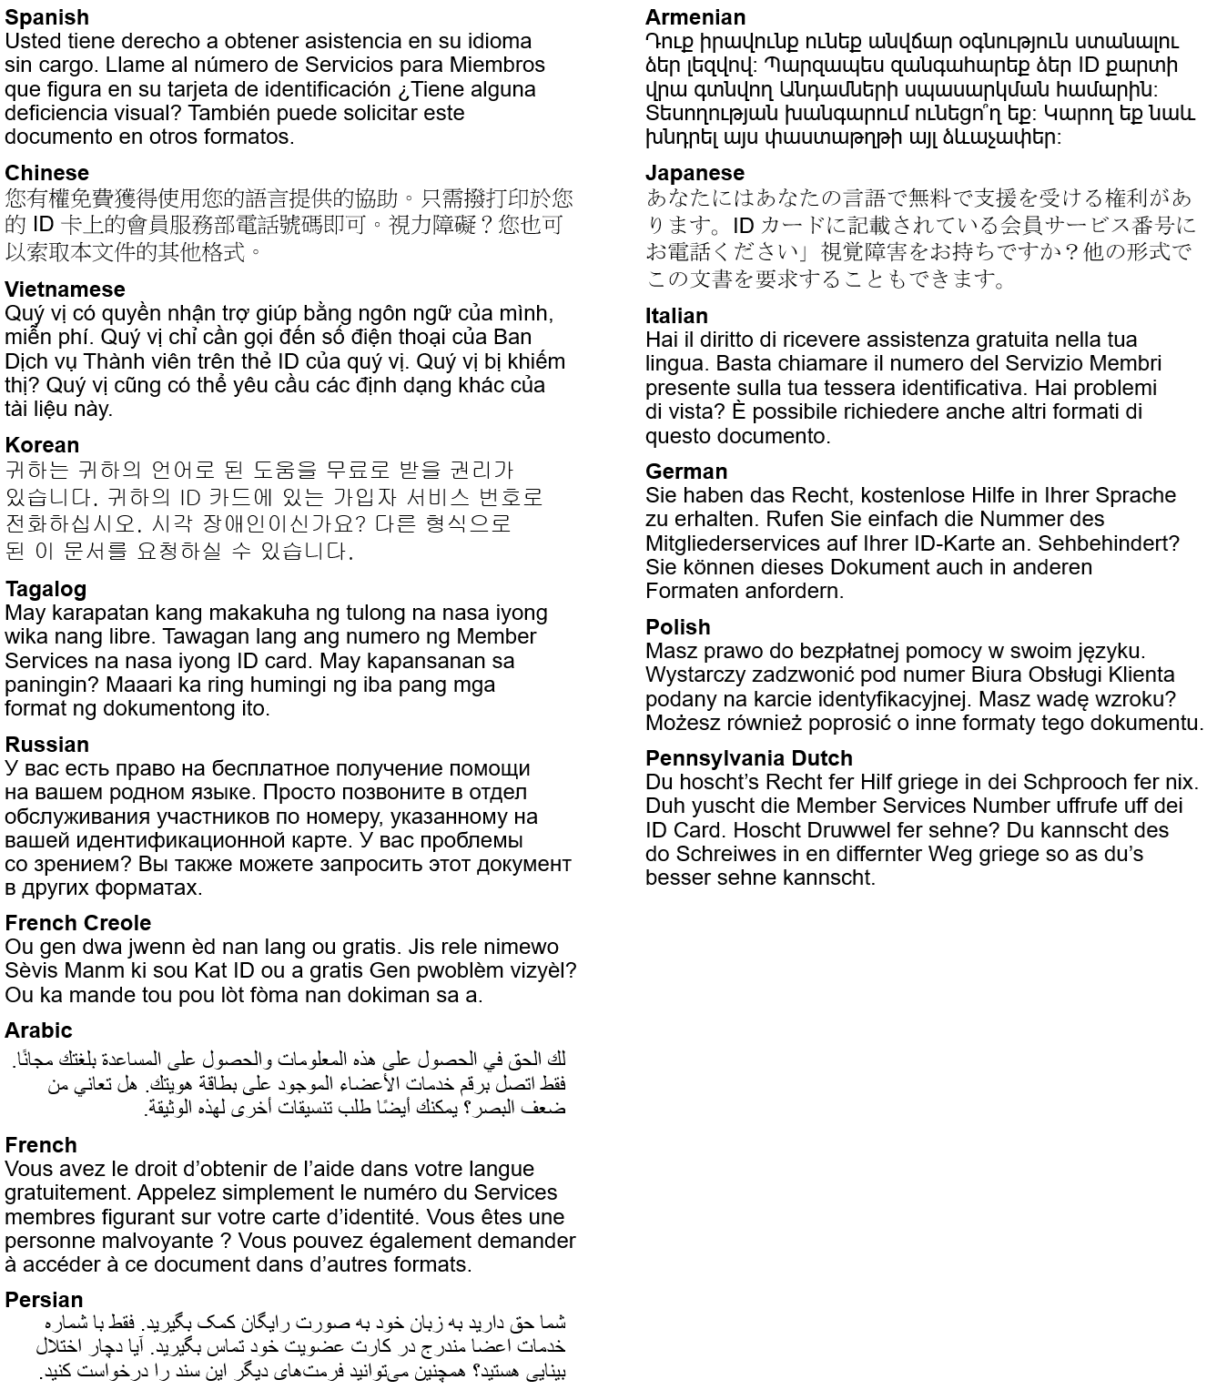
The law requires us to include a message in all of these different languages. Curious what they say? Here’s the English version: “You have the right to get help in your language for free. Just call the Member Services number on your ID card.” Visually impaired? You can also ask for other formats of this document

TTY/TTD:711

It’s important we treat you fairly
We follow federal civil rights laws in our health programs and activities. Members can get reasonable modifications as well as free auxiliary aids and services if you have a disability. We don’t discriminate, on the basis of race, color, national origin, sex, age or disability. For people whose primary language isn’t English (or have limited proficiency), we offer free language assistance services like interpreters and other written languages. Interested in these services? Call the Member Services number on your ID card for help (TTY/TDD: 711) or visit our website. If you think we failed in any areas or to learn more about grievance procedures, you can mail a complaint to: Compliance Coordinator, P.O. Box 27401, Richmond, VA 23279, or directly to the U.S. Department of Health and Human Services, Office for Civil Rights at 200 Independence Avenue, SW; Room 509F, HHH Building; Washington, D.C. 20201. You can also call 1-800- 368-1019 (TDD: 1-800-537-7697) or visit https://ocrportal.hhs.gov/ocr/portal/lobby.jsf

