City of Evansville



*Request for Proposal*

RFP-01-604-18

For

Locust Hill Cemetery and Oak Hill Cemetery

Annual Landscape Maintenance

Issue Date: January 5, 2018

Issued By: City of Evansville Purchasing Department

Civic Center Complex – Room 323

1 NW Martin Luther King Blvd.

Evansville, IN 47708

Issued Via: Email

Inquiries: Questions should be submitted via Email to:

Debra Spalding

Purchasing

dspalding@evansville.in.gov

Pre-bid Meeting: January 22, 2018 at 2:00 PM CST

Superintendent’s Office - 1400 E. Virginia Street

Proposals Due: February 8, 2018 by 1:30 PM CST

Table of Contents

VENDOR INSTRUCTIONS

PAGE:

1. Introduction 1
2. General Requirements 1
3. Response Instructions 1
4. Contact with Municipality Employees 1
5. Assess RFP Documents 1
6. Costs of RFP Preparation and Submission 1
7. Bid Bond and Performance Bond 1
8. Public Opening Procedures 2
9. Proposal Review 2
10. Proposal Format and Form 3
11. Delivery of Proposals 3

PROPOSAL EVALUATION

PAGE:

1. Evaluations 4
2. Right to Discussions 4
3. Right of Refusal 4
4. Subcontractors 4
5. Minority and Women Business Enterprise Utilization 5
6. E-Verify Program 5
7. Taxes 5
8. Licenses and Permits 5
9. Choice of Law and Venue 5

SPECIFICATIONS

PAGE:

Oak Hill Cemetery Specifications A-1

Locust Hill Cemetery Specifications B-1

REQUIRED FORMS

PAGE:

Bidders Checklist C-1

Tabulation Page D-1

Equal Employment Opportunity E-1

Indiana legal Employment Declaration F-1

Conflict of Interest G-1

Map Overlays H-1

**1. INTRODUCTION**

The Board of Public Works (the “Board”) for Oak Hill and Locust Hill Cemetery (the “Owner”) and the City of Evansville (the "City"), is soliciting competitive sealed proposals from qualified contractors to provide complete lawn care services at Oak Hill and/or Locust Hill Cemeteries. Your company, among others, is invited to submit a proposal on a competitive basis in the format described in this Request for Proposal (RFP). This RFP establishes requirements and defines responsibilities of the proposing vendor (hereinafter "Vendor", “Respondent”, or “Contractor”) to provide lawn care services, as described under Specifications A Oak Hill Cemetery (page A-1) and Specifications B Locust Hill Cemetery (page B-1).

**2. GENERAL REQUIREMENTS**

The responsibilities of the Contractor include, but shall not be limited to, the following:

1. The Contractor shall purchase all items needed to provide services.
2. The Contractor will furnish all tools and labor required for installation.
3. The Contractor shall coordinate with Owner Director or his designee for time and space to complete all work required.

**3. RESPONSE INSTRUCTIONS**

The submitted proposal must follow the rules and format established within this RFP. Adherence to these rules will ensure a fair and objective analysis of all proposals. Failure to complete any portion of this request may result in rejection of a proposal.

**4. CONTACT WITH MUNICIPALITY EMPLOYEES**

To ensure a fair and objective evaluation of all proposals, vendors are required to submit all inquiries in writing to the Purchasing Department at [dspalding@evansville.in.gov](mailto:dspalding@evansville.in.gov) . Each Email should be titled: *Cemetery Lawn Care 2018*.

Inquiries shall be submitted to the Purchasing Department no later than 72 hours prior to the stated opening time and date. This is to allow for ample time to respond and disseminate to all perspective parties.

All changes in specifications shall be in writing in the form of an addendum and furnished to all contractors. Verbal information obtained otherwise will not be considered in awarding of proposal. No changes to specifications will be permitted within five (5) days prior to the proposal opening.

**5. ASSESS RFP DOCUMENTS**

Before submitting a proposal, vendors shall examine the specifications in order to understand all existing conditions and limitations.

**6. COSTS OF RFP PREPARATION AND SUBMISSION**

Each vendor shall be responsible for all costs incurred in order to prepare and submit their response to this RFP.

**7. BID BOND AND PERFORMANCE BOND**

1. Bid Bond, Certified Check, Cashier’s Check or Bank Draft in the amount of five percent (5%) of the total quote shall accompany each quote as a guarantee that all provisions of the specifications shall be met.
2. Bid Bonds and Checks will be returned to the unsuccessful Vendor(s) after award of purchase by the Board of Public Works/City and to the successful Vendor(s) after the performance bond, if required, has been received and accepted.
3. Bid Bonds must be executed by a corporate surety licensed under the laws of Indiana to execute such bonds. The surety must be a corporate surety authorized to do business in Indiana and Power of Attorney must accompany the Quote Bond.
4. A Performance Bond in the amount of One Hundred percent (100%) of the total contract amount will be required of the successful Vendor, prior to work beginning, as a guarantee that all provisions of the quote and attached specifications, and resulting contract, shall be met.

The Performance Bond is to be posted with the Board within ten (10) business days after award. Failure to post said Bond may result in the immediate revocations of award.

In place of the bond, a certified check or cashier’s check in the full amount of the contract may be provided. Such deposits must be filed with the executed contract documents and made a part thereof. It shall be the responsibility of the Vendor to include the cost of the Performance Bond in the quote. The Board /City will not pay an additional amount at a later date.

**8. PUBLIC OPENING PROCEDURES**

1. The purpose of a public opening is for a reading of responses received. Under normal circumstances, no award will be made or implied at this time, unless otherwise indicated.
2. Only the following information will be given:
   1. Vendor name
3. Proposals or related documents may not be reviewed at the proposal opening. No discussion of any nature concerning brand names, deliveries, samples, etc. can be entered into between any Purchasing personnel and any Vendor during or after the proposal opening until the evaluation of proposals has been completed and an award has been made by the Board of Public Works.
4. A copy of the Proposal tabulation will be available to review in the Purchasing Department upon completion of the recommended award.
5. Vendors who wish to review or request copies of quotes may do so by contacting the Purchasing Department. A copy fee will be charged for copies.

**9. PROPOSAL REVIEW**

All documents submitted as part of the Vendor’s proposal will be deemed confidential during the evaluation process. Vendor proposals will not be available for review by anyone other than the evaluation team or its designated agents. There shall be no disclosure of any Vendor’s information to a competing Vendor prior to award of the contract. All applicable information will be subject to public disclosure in accordance with the Freedom of Information Act, at award of contract, cancellation of this RFP, or within 180 days, whichever shall occur first.

**10. PROPOSAL FORMAT AND FORMS**

Each proposal will be prepared in the format specified, incorporating the additional forms provided at the end of this document, and be submitted in a sealed envelope bearing the title of work and the name of the vendor. One (1) original and one (1) complete copy of proposal shall be provided.

**11. DELIVERY OF PROPOSALS**

The submittals should be sealed and clearly labeled as **“*City Cemeteries Lawn Care RFP-01-604-18.*”** It is the sole responsibility of the vendor to see that their RFP is received in the proper time. Any proposal received after the proposal opening date and time shall be eliminated from consideration and returned to the vendor unopened.

**RFPs must be delivered by 1:20 PM CST on February 8, 2018** to the following address:

City of Evansville  
Purchasing Department  
1 NW Martin Luther King, Jr. Blvd, Room 323

Evansville, Indiana 47708

**NOTE: Any proposals submitted after 1:20 PM CST on February 8, 2018, but before the scheduled opening at 1:30 PM CST shall be delivered to BPW Board, Civic Center - Room 301, 1 NW Martin Luther King Jr. Blvd., Evansville, Indiana 47708.**

1. **EVALUATIONS**

An evaluation team will evaluate proposals on a variety of qualitative criteria as specified below. The proposal(s) selected shall be the lowest responsive and responsible bidder that provides the most comprehensive approach that meets the stated requirements.

The primary criteria for vendor evaluation and consideration are:

* Price quoted by the Contractor. *(Tabulation Page D-2)* (30%)
* Contractor’s ability to perform the services hereunder including, but not limited to the manpower level and the equipment to be used. *(See Specifications A & Specifications B, Paragraph 5. Qualifications, Section A. Minimum Qualifications, Lines 2-4)* (25%)
* Experience in mowing and maintaining cemeteries, governmental properties and/or large commercial properties. *(See Specifications A & Specifications B, Paragraph 5. Qualifications, Section B. Statement of Experience, Lines 1-3)* (25%)
* Comments from references . *(See Specifications A & Specifications B, Paragraph 5. Qualifications Section A. Minimum Qualifications, Line 1)* (20%)

The agency may award based on initial proposals received, without discussion of such proposals. Selected vendors may be invited to make oral or written presentations to the evaluation team.

1. **RIGHT TO DISCUSSIONS**

The agency reserves the right to conduct discussions with Respondents for the purpose of clarification to assure full understanding of, and responsiveness to, the solicitation requirements. The agency further reserves the right to excuse technical defects in a proposal when, in its sole discretion, such excuse is beneficial to the agency.

1. **RIGHT OF REFUSAL**

The Board reserves the right to reject any one or all RFPs, or any part of any RFP, to waive any informality in any quote, and to award the purchase in the best interest of the Board /City. Furthermore, the /City reserves the right to hold the quote of the three (3) lowest Vendors for a period of sixty (60) calendar days from and after the time of the quote opening.

1. **SUBCONTRACTORS**

The Board intends to contract with one prime Contractor, per site, who will be solely responsible for contractual performance. In the event the prime Contractor utilizes one or more subcontractors, the prime Contractor will assume any/all responsibility for performance of services by the subcontractor(s). Additionally, the City of Evansville must be named as a third party beneficiary in all subcontracts.

A list of all subcontractors proposed to take part in the performance of the contract must be provided to the City of Evansville for approval prior to contract execution. This request may require that sufficient financial or background information pertaining to included subcontractors be provided.

The City of Evansville reserves the right to limit and/or reject any and all subcontractors.

**5.** **MINORITY AND WOMEN BUSINESS ENTERPRISE UTILIZATION**

The City of Evansville formally adopted a Minority and Women Business Utilization Plan illustrating a commitment to achieving significant utilization of Minority and Women Business Enterprises (M/WBE) in the community’s purchasing efforts. Goals have been established to provide an atmosphere of equal opportunity for all vendors and to prohibit discrimination in all aspects of the public operations including the purchasing of products, services, and public works contracts. (See City of Evansville Municipal Code 3.90.110-180)

**6. E-VERIFY PROGRAM**

Pursuant to Indiana Code 22-5-1.7-11 (b)(2) the Contractor shall provide documentation that it has enrolled and is participating in the E-Verify Program (see Indiana Legal Employment Declaration form). Contractor is required to submit proof from the E-Verify Program that it is currently enrolled in the Program. An example of confirmation is the confirmation e-mail received from E-Verify that the Contractor has successfully enrolled in E-Verify.

**7.** **TAXES**

The City of Evansville is exempt from Federal, State, and Local Taxes and will not be responsible for any such taxes in connection with the award or performance of this contract.

**8. LICENCES AND PERMITS**

The successful Vendor or Vendors shall furnish the City of Evansville upon request any and all documentation regarding licenses, permits, certifications and/or registrations required by the laws and regulations of the City of Evansville, Vanderburgh County, the State of Indiana and the United States of America.

The provider certifies that it is now and will remain in good standing with the aforementioned governmental agencies and that it will maintain its licenses, permits, certifications and/or registrations in force during the term of the contract/agreement with the City of Evansville, Vanderburgh County, Indiana.

**9. CHOICE OF LAW AND VENUE**

Any and all actions or proceedings arising out of, or related to, this RFP and any resulting contract shall be governed by and construed in accordance with the laws of the State of Indiana. Submission of this proposal by Vendor constitutes consent and stipulation to jurisdiction and venue in the courts of Vanderburgh County, Indiana, concerning all litigation and proceedings arising out of or related to this RFP and any resulting contract.

**SPECIFICATIONS FOR LANDSCAPE MAINTENANCE**

**AT OAK HILL CEMETERY**

**1400 E. Virginia Street**

**1. LENGTH OF CONTRACT**

Contract will be from January 01, 2018 through December 31, 2018. Contract is for one (1) year with up to two (2) extensions of one (1) year each, for a total of three (3) years upon mutual agreement by both parties.

**2. SCOPE OF SERVICES**

The successful bidder, hereinafter called the “Contractor,” will furnish scheduled landscape maintenance for approximately thirty-nine (39) rotations per year in accordance with the terms and conditions set forth in the contract.

This number is based on starting mid-March and ending mid-December. However, due to the climactic nature of this service, no set time for beginning or ending can be given. The service will begin and end at the discretion of the Superintendent of the Evansville Cemeteries.

The contractor must comply with all rules, regulations and laws of the Board of Public Works, City of Evansville and the State of Indiana.

**3. SUPERVISION AND INSPECTION**

The Superintendent of the Evansville Oak Hill Cemetery or that person designated will maintain a continuing inspection to determine if Contractor is complying with all provisions of the contract.

This inspection will include but will not be limited to, the quality of service rendered and the regularity of that service and non-discrimination policies of the Contractor with relation to their employees and service to the public.

The Contractor and its employees will be required to adhere to the rules and regulations of Oak Hill Cemetery and to cooperate with the Superintendent meeting the demands of the public.

**4. SERVICES REQUIRED**

The following services are to include all areas within the boundaries of Oak Hill Cemetery and the exterior of the brick wall and fence that surrounds the property, including the optional area along Morgan Avenue and the farm field as designated by the Cemetery Superintendent as Bush Hogg Area.

1. Mowing, trimming and cleanup of all grass on a five (5) day rotation basis during the months of March, and April. During May, June, July, August, September, October, November, and December, a seven (7) day rotation basis is to be used. Each cutting of the premises shall be completed within five (5) days of the start of each cut, weather permitting.
2. All grass considered under this agreement is to be maintained at a height of approximately three (3) inches. Special attention must be paid to trimming areas near and/or around monuments, fresh graves, lakes, walls, fences, bushes, curbs, streets, paths, buildings and other similar objects.
3. The field at Oak Hill beside Hemlock Drive and north of Maple Lane shall be mowed as determined by The Superintendent of the Evansville Oak Hill Cemetery or that person designated.
4. All cut grass, weeds, yard waste, etc. must be swept or blown from roadways, paths, sidewalks, monuments and monument areas, etc., as a section is completed. No new area is to be started until all cut grass, weeds, yard waste, etc. has been swept or blown from roadways, paths, sidewalks, monuments and monument areas, etc. of the current section being cut. See Map on page B-4.
5. Mulching decks or attachments are to be utilized on all mowers unless authorized by the Superintendent. Decks are to have protection against potential monument damage.
6. Bush Hogg Area:
7. Bush Hogg Area is to be bid separately from Oak Hill pricing. This area is currently maintained by cemetery personnel. Owner is entertaining having this area outsourced.
8. Bush Hogging is to be completed as determined The Superintendent of the Evansville Oak Hill Cemetery or that person designated in areas designated by map on page H-1. Both sides of fence line along Morgan Avenue with one pass on the inside and 3 passes on outside of fence. This is to be bid as a separate item per cut.
9. Collection and disposal of trash, debris, litter, limbs, cut grass, weeds, leaves, etc.
10. Leaf Removal:
11. Leaves are to be mulched and left in place unless it is deemed necessary by the Superintendent to rake and remove them.
12. Leaves that are raked and removed are to be wind-rowed and composted in an area designated by the Superintendent.
13. Leaves that are raked are to be moved to the composting area on the same day they are raked.
14. Trash and Debris:
15. All non-permanent items (excluding floral arrangements) including, but not limited to limbs, litter, trash, debris, cut grass, cans, bottles, paper, etc. must be collected and properly disposed of.
16. Organic material may be collected and placed in an area designated by the Superintendent.
17. Non-organic material (including paper, cans, bottles, etc.) must be collected and placed in a dumpster designated for that purpose.

It is the intention of the Board of Public Works and the City of Evansville that the contract shall provide for the proper maintenance of the Oak Hill Cemetery grounds in order that the Cemetery presents an attractive and well-maintained appearance to the citizens of Evansville.

**5. QUALIFICATIONS**

1. Minimum Qualifications:
2. Contractor must submit three (3) local references including cemeteries, commercial, and/or governmental mowing contracts.
3. Contractor must submit detailed listing of equipment to be used to maintain grounds.
4. List of manpower to be utilized.
5. Detailed plan of action, i.e. – how many employees to be used on a daily basis and jobs they will be performing.
6. All equipment, materials, fuel, etc. to maintain grounds are to be supplied by the Contractor.
7. Contractor and their employees must present themselves in a professional manner at all times; employees must be in uniform or company t-shirt. Offensive clothing and language will not be tolerated. This is at the discretion of the cemetery Superintendent. Shirts are to be worn at all times.
8. The use of alcohol or illegal drugs will not be tolerated
9. Statement of Experience: Contractor must state:
   1. How long business has been in existence doing mowing and lawn maintenance
   2. Number of years experience in lawn mowing and maintenance of supervisory personnel
   3. Any prior experience mowing cemeteries

1. Emergency Planning
2. What additional equipment and personnel does the contractor have available in the event the weather causes damage or delay in required maintenance.

1. Non-Compliance
2. Contractor will be required to obtain a Performance Bond equal to the amount of the contract. The Contractor also agrees that should Contractor fail to comply with the terms of the contract, Contractor will be given four (4) days to bring in such non-compliance to compliance. If contractor fails to correct such non-compliance, the City may do one or more of the following:
   * 1. Exercise its right to collect on the Performance Bond
     2. Terminate the contract and pay the Contractor only to the date of termination less any amounts owed to the city by the Contractor
     3. Use its own workers or hire another contractor to remedy the breach and withhold from payments due the Contractor the cost of such corrective measures
     4. Any other remedy allowed at law or equity

1. Use of Space Located on Cemetery Grounds
2. An area can be provided if the Contractor would like to store a trailer for personal use. The surrounding area is to be kept clean and neat at all times. Insurance on personnel items is to be provided by Contractor.

1. Performance Bond

1. The contractor agrees to make, execute and deliver, as soon as it is practical after the execution of this agreement but not later than the beginning of the work, of the year of the contract, a Performance Bond to the Board of Public Works with a surety company authorized to do business in the State of Indiana a surety in the sum of one hundred percent (100%) of the total contract award for the faithful performance of all conditions or covenants contained herein.

1. Insurance
2. The Contractor shall procure and keep in force during the term of the contract, General Liability insurance indemnifying the Board of Public Works and The City of Evansville against claims for injuries and death arising out of its maintenance of the premises in the amount of at least ($1,000,000) one million dollars combined single limit for each occurrence and Contractor shall also procure property damage insurance indemnifying the Board of Public Works and the City of Evansville from and against any and all claims in the amount of not less than ($100,000) one hundred thousand dollars. Contractor shall carry worker’s compensation insurance coverage in amounts required by Indiana law for all of its employees who perform work under the contract.
3. The City of Evansville shall be named as additional insured on such Public Liability Insurance. Certificates of insurance must be presented to the Board of Public Works or its designated representative (Purchasing Department) prior to the commencement of the contract.

1. Damage to Premises
2. If the cemetery property or contents is damaged in any way whatsoever by reason of any act or omission of the Contractor or its employees, the Contractor shall immediately repair at its own cost and expense the building, structure, wall, fence, fresh grave, monument/s, etc. as damaged.
3. Upon failure of the Contractor to make such repairs, the Board of Public Works and/or the City of Evansville may repair such damage at the cost and expense of the Contractor and shall have the right to terminate the contract.
4. Payment for Services
   * + 1. Contractor is to understand payment for services rendered under contract will not occur until services are complete and a valid invoice is submitted
       2. Once services have been rendered under contract and a valid invoice has been submitted, the Superintendent of the Evansville Oak Hill Cemetery or that person designated shall submit the invoice for payment to the City Finance Department for payment
       3. The City Finance Department will inspect the invoice and submit it to the Board of Public Works (BPW) for approval for payment
          1. The above may take up to eight weeks depending on meeting times of the BPW

J. Contractor’s Initials _______________

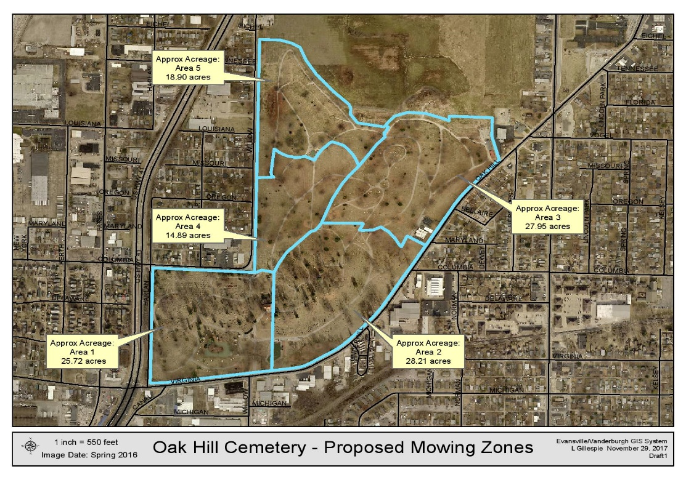

1. **SPECIFICATIONS FOR LANDSCAPE MAINTENANCE**

**AT LOCUST HILL CEMETERY**

**3800 KRATZVILLE ROAD**

**1. LENGTH OF CONTRACT**

Contract will be from January 01, 2018 through December 31, 2018. Contract is for one (1) years with up to two (2) extensions of one (1) year each, for a total of three (3) years upon mutual agreement by both parties.

**2. SCOPE OF SERVICES**

The successful bidder, hereinafter called the “Contractor,” will furnish scheduled landscape maintenance for approximately thirty-nine (39) rotations per year in accordance with the terms and conditions set forth in the contract.

This number is based on starting mid-March and ending mid-December. However, due to the climactic nature of this service, no set time for beginning or ending can be given. The service will begin and end at the discretion of the Superintendent of the Evansville Cemeteries.

The contractor must comply with all rules, regulations and laws of the Board of Public Works, City of Evansville and the State of Indiana.

**3. SUPERVISION AND INSPECTION**

The Superintendent of the Evansville Cemeteries or that person designated will maintain a continuing inspection to determine if Contractor is complying with all provisions of the contract.

This inspection will include but will not be limited to, the quality of service rendered and the regularity of that service and non-discrimination policies of the Contractor with relation to their employees and service to the public.

The Contractor and its employees will be required to adhere to the rules and regulations of Locust Hill Cemetery and to cooperate with the Superintendent meeting the demands of the public.

**4. SERVICES REQUIRED**

The following services are to include all areas within the boundaries of Locust Hill Cemetery and the exterior of the brick wall and fence that surrounds the property, excluding that area along Kratzville Road and the farm field as designated by the Cemetery Superintendent.

1. Mowing, trimming and cleanup of all grass on a five (5) day rotation basis during the months of March, and April. During May, June, July, August, September, October, November, and December, a seven (7) day rotation basis is to be used. Each cutting of the premises shall be completed within (5) days of the start of each cut, weather permitting.
2. All grass considered under this agreement is to be maintained at a height of approximately three (3) inches. Special attention must be paid to trimming areas near and/or around monuments, fresh graves, lakes, walls, fences, bushes, curbs, streets, paths, buildings and other similar objects.
3. The field behind Locust Hill office and maintenance building shall be mowed not less than every other week. (Area 4 on Area Map)
4. All cut grass, weeds, yard waste, etc. must be swept or blown from roadways, paths, sidewalks, monuments and monument areas, etc., as a section is completed. No new area is to be started until all cut grass, weeds, yard waste, etc. has been swept or blown from roadways, paths, sidewalks, monuments and monument areas, etc. of the current section being cut. See Area Map on page B-8.
5. Mulching decks or attachments are to be utilized on all mowers unless authorized by the Superintendent. Decks are to have protection against potential monument damage.
6. Collection and disposal of trash, debris, litter, limbs, cut grass, weeds, leaves, etc.
7. Leaf Removal –
8. Leaves are to be mulched and left in place unless it is deemed necessary by the Superintendent to rake and remove them.
9. Leaves that are raked and removed are to be wind-rowed and composted in an area designated by the Superintendent.
10. Leaves that are raked are to be moved to the composting area on the same day they are raked.
11. Trash and Debris –
12. All non-permanent items (excluding floral arrangements) including, but not limited to limbs, litter, trash, debris, cut grass, cans, bottles, paper, etc. must be collected and properly disposed of.
13. Organic material may be collected and placed in an area designated by the Superintendent.
14. Non-organic material (including paper, cans, bottles, etc.) must be collected and placed in a dumpster designated for that purpose.

It is the intention of the Board of Public Works and the City of Evansville that the contract shall provide for the proper maintenance of the Locust Hill Cemetery grounds in order that the Cemetery presents an attractive and well-maintained appearance to the citizens of Evansville.

**5. QUALIFICATIONS**

1. Minimum Qualifications:
2. Contractor must submit three (3) local references including cemeteries, commercial, and/or governmental mowing contracts.
3. Contractor must submit detailed listing of equipment to be used to maintain grounds.
4. List of manpower to be utilized.
5. Detailed plan of action, i.e. – how many employees to be used on a daily basis and jobs they will be performing.
6. All equipment, materials, fuel, etc. to maintain grounds are to be supplied by the Contractor.
7. Contractor and their employees must present themselves in a professional manner at all times; employees must be in uniform or company t-shirt. Offensive clothing and language will not be tolerated. This is at the discretion of the cemetery Superintendent. Shirts are to be worn at all times.
8. The use of alcohol or illegal drugs will not be tolerated
9. Statement of Experience: Contractor must state:
   1. How long business has been in existence doing mowing and lawn maintenance
   2. Number of years experience in lawn mowing and maintenance of supervisory personnel
   3. Any prior experience mowing cemeteries

1. Emergency Planning
2. What additional equipment and personnel does the contractor have available in the event the weather causes damage or delay in required maintenance.

1. Non-Compliance
2. Contractor will be required to obtain a Performance Bond equal to the amount of the contract. The Contractor also agrees that should Contractor fail to comply with the terms of the contract, Contractor will be given four (4) days to bring in such non-compliance to compliance. If contractor fails to correct such non-compliance, the City may do one or more of the following:
3. Exercise its right to collect on the Performance Bond
4. Terminate the contract and pay the Contractor only to the date of termination less any amounts owed to the city by the Contractor
5. Use its own workers or hire another contractor to remedy the breach and withhold from payments due the Contractor the cost of such corrective measures
6. Any other remedy allowed at law or equity

1. Use of Space Located on Cemetery Grounds
2. An area can be provided if the Contractor would like to store a trailer for personal use. The surrounding area is to be kept clean and neat at all times. Insurance on personnel items is to be provided by Contractor.

1. Performance Bond

1. The contractor agrees to make, execute and deliver, as soon as it is practical after the execution of this agreement but not later than the beginning of the work, of the year of the contract, a Performance Bond to the Board of Public Works with a surety company authorized to do business in the State of Indiana a surety in the sum of one hundred percent (100%) of the total contract award for the faithful performance of all conditions or covenants contained herein.

1. Insurance
2. The Contractor shall procure and keep in force during the term of the contract, General Liability insurance indemnifying the Board of Public Works and The City of Evansville against claims for injuries and death arising out of its maintenance of the premises in the amount of at least ($1,000,000) one million dollars combined single limit for each occurrence and Contractor shall also procure property damage insurance indemnifying the Board of Public Works and the City of Evansville from and against any and all claims in the amount of not less than (100,000) one hundred thousand dollars. Contractor shall carry worker’s compensation insurance coverage in amounts required by Indiana law for all of its employees who perform work under the contract.
3. The Board of Public Works and the City of Evansville shall be named as additional insured on such Public Liability Insurance. Certificates of insurance must be presented to the Board of Public Works or its designated representative prior to the commencement of the contract.

1. Damage to Premises
2. If the cemetery property or contents is damaged in any way whatsoever by reason of any act or omission of the Contractor or its employees. The Contractor shall immediately repair at its own cost and expense the building, structure, wall, fence, fresh grave, monument/s, etc. as damaged.
3. Upon failure of the Contractor to make such repairs, the Board of Public Works and/or the City of Evansville may repair such damage at the cost and expense of the Contractor and shall have the right to terminate the contract.

1. Payment for Services
2. Contractor is to understand payment for services rendered under contract will not occur until services are complete and a valid invoice is submitted.
3. Once services have been rendered under contract and a valid invoice has been submitted, the Superintendent of the Evansville Oak Hill Cemetery or that person designated shall submit the invoice for payment to the City Finance Department for payment.
4. The City Finance Department will inspect the invoice and submit it to the Board of Public Works (BPW) for approval for payment.
   1. The above may take up to eight weeks depending on meeting times of the BPW.

J. Contractor’s Initials _______________

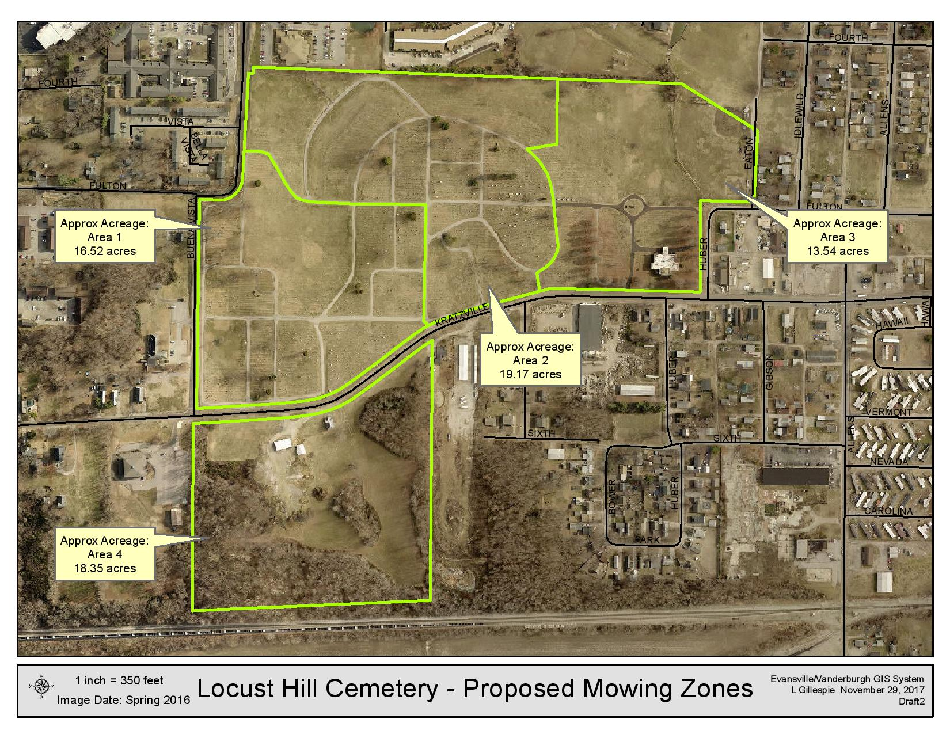

BIDDER'S CHECKLIST:

In order to be accepted as a valid RFP submission, the following items MUST be included with your bid, along with any other information requested in the specifications.

1. **Specifications A (initial bottom of page A-4)**
2. **Specifications B (initial bottom of page B-3)**
3. **Tabulation Pages**

(w/signed and notarized Non-Collusion Affidavit)

1. **Equal Employment Opportunity Statement**
2. **E-Verify Affidavit**
3. **Conflict of Interest / Familial Disclosure Form ______**
4. **Minimum Qualifications**

*(See Specifications A & Specifications B, Paragraph 5. Qualifications, Section A. Minimum Qualifications, Lines 2-4)*

1. **Statement of Experience**

*(See Specifications A & Specifications B, Paragraph 5. Qualifications, Section B. Statement of Experience, Lines 1-3)*

1. **List of References**

*(See Specifications A & Specifications B, Paragraph 5. Qualifications, Section A. Minimum Qualifications, Line 1)*

1. **Bid Bond**

DATE: January 5, 2018

The Board of Public Works / City of Evansville invites your proposals for the following items:

**LAWN CARE SERVICES OAK HILL CEMETERY & LOCUST HILL CEMETERY**

**RFP-01-604-18**

to be opened at 1:30 pm CST on Thursday, February 8, 2018 in Room 301 of the Civic Center Complex.

Legal notice has been published in The Evansville Courier (January 5, 2018 & January 12, 2018).

The undersigned proposes to furnish and deliver, in accordance with the requirements of the Instructions to Bidders and the Specifications dated January 22, 2018 prepared by the City of Evansville Purchasing Department, the following contract for the time period beginning January 1, 2018.

Please be advised that any alterations, changes in bid format, etc. will make it difficult to evaluate proposals and may lead to confusion. All items should be bid in the units, quantities, and units of measurements specified. Do not submit alternate proposals unless requested. The City of Evansville and the Board of Public Works shall reserve the right to reject any or all proposals or any part thereof.

**QUOTATIONS**

1. All prices F.O.B. to 1400 E. Virginia Ave. & 3800 Kratzville Road, Evansville, Indiana, 47708. Yes No

2. Discounts, if any, if awarded entire contract _________________________________________________

3. Bidder will accept a portion of the contract award ________________

(initial)

or total contract only ________________

(initial)

**BID BOND**

Bidder has submitted a 5% Bid Bond? Yes No

**INDEMNIFICATION**

Bidder will indemnify and hold harmless the City of Evansville and Vanderburgh County in accordance with the provisions contained herein? Yes No

**BIDDER QUALIFICATION AND EXPERIENCE**

1. Bidder has included three (3) references? Yes No

2. Bidder possesses necessary occupational license(s)? Yes No

In accordance with the attached instructions, conditions, and specifications,

______________________________________________________ (firm) submits the following bid/proposal:

(Company Name)

**DESCRIPTION PRICE**

1. **Lawn Care Services Oak Hill Cemetery (Specifications A) $**

**Written Form**

1. **Bush Hogg Services Oak Hill Cemetery (per cut) $**

**Written Form**

1. **Lawn Care Service Locust Hill Cemetery (Specifications B) $**

**Written Form**

1. **TOTAL Price if Awarded All $**

*(If different from sum of above pricing)*

**Written Form**

------------------------------------------------------------------------------------------------------------------------------------------------------

Bidder agrees that they will not withdraw their proposal from the City in which it is filed. A certified check or bond shall be filed with each proposal, if required, and liability for breach shall be enforceable upon the contract, the bond or certified check or both as the case may be.

**NON-COLLUSION AFFIDAVIT**

The undersigned bidder or agent, being duly sworn on oath, says that they have not, nor has any other member, representative, or agent of the firm, company, corporation or partnership represented by them, entered into any combination, collusion or agreement with any person relative to the price to be bid by anyone at such letting nor to prevent any person from bidding nor to induce anyone to refrain from bidding, and that this bid is made without reference to any other bid and without an agreement, understanding or combination with any other person in reference to such bidding. Bidder further says that no person or persons, firms, or corporation has, has or will receive directly or indirectly, any rebate, fee, gift, commission or thing of value on account of such sale.

**___________________________________ ________________________________**

**AUTHORIZED SIGNATURE DATE**

**___________________________________ ________________________________**

**NAME & TITLE (PLEASE PRINT) TELEPHONE**

**__________________________________ ________________________________**

**COMPANY NAME FAX**

**__________________________________ ________________________________**

**ADDRESS (STREET) CITY, STATE, ZIP CODE**

**Subscribed and sworn to before me this ______ day of ________________, 20___.**

**My Commission Expires:________________ ______________________________________**

**Notary Public**

**County of Residence**: **_______________________________________________**

**ACCEPTANCE**

There now being sufficient unobligated appropriated funds available, the contracting authority of

____________________________________ (“Governmental Unit”) hereby accepts the terms of the attached bid for classes or items numbered ____________________________ and promises to pay the undersigned bidder upon delivery the price quoted for the materials/equipment stipulated in said bid.

Contracting Authority Members: Date: ___________________________

___________________________________________ ________________________________

___________________________________________ ________________________________

___________________________________________ ________________________________

During the performance of the contract, the Contractor agrees as follows:

1. The contractor will not discriminate against any employee or applicant for employment because of race, color, religion, sex, national origin political affiliation or belief, age or disability. The Contractor will take affirmative action to insure that applicants are employed, and that employees are treated during employment, without regard to race, color, religion, sex, national origin, political affiliation or belief, age, or disability. Such action shall include but not be limited to the following: employment, upgrading, demotion, or transfer, recruitment or recruitment advertising, layoff or termination, rates of pay or other forms of compensation, and selection for training, including apprenticeship. The Contractor agrees to post in conspicuous places, available to employees and applicants for employment, notice setting forth the provisions of the nondiscrimination clause.

2. The Contractor agrees that all services, facilities, activities and programs provided as part of this contract will meet the requirements of the American’s with Disabilities Act and the rules and regulations promulgated thereunder.

3. The Contractor will, in all solicitations or advertisements for employees placed by or on behalf of the Contractor; state that all qualified applicants will receive consideration for employment without regard to race, color, religion, sex, national origin, political affiliation or belief, age or disability.

4. The Contractor will send to each labor union or representative of workers with which he has a collective bargaining agreement or other contract or understanding, a notice, to be provided, advertising, the labor union or workers’ representative of the Contractor’s commitments under the Equal Employment Opportunity Section of this contract, and shall post copies of the notice in conspicuous places available to employees and applicants for employment.

1. In the event of the Contractor’s noncompliance with the noncompliance clauses of this contract or with any of such rules, regulations, or orders, this contract may be cancelled, terminated, or suspended in whole or in part and the Contractor may be declared ineligible for further City/County contract.

____________________________________ _________________________________

Vendor Representative (Please Print) Signed

____________________________________ _________________________________

Vendor Name Telephone

____________________________________ _________________________________

Vendor Address Date

**INDIANA LEGAL EMPLOYMENT DECLARATION**

The State of Indiana has enacted a law (I.C. 22-5-1.7) requiring all state agencies and political subdivisions request verification from their contractors that their employees are legally eligible to work in the United States. This Declaration serves as notice that all Contractors doing business with the City of Evansville must, as a term of their contract:

1. Enroll in and verify the work eligibility status of newly hired employees of the contractor through the E-Verify programs (but is not required to do this if the E-Verify program no longer exists); and
2. Verify, by signature below, that the Contractor does not knowingly employ unauthorized aliens.

I, __________________________, a duly authorized agent of ____________________(name of Company), declare under penalties of perjury that __________________________(name of Company) does not employ unauthorized aliens to the best of its knowledge and belief.

____________________________________

(Name of Company)

By:____________________________________

(Authorized Representative of Company)

Subscribed and sworn to before me on this ___________day of ______________, 20___.

My Commission Expires: _________________

County of Residence: ___________________

_____________________________________

Notary Public – Signature

_____________________________________

Notary Public – Printed Name

**CONFLICT OF INTEREST / FAMILIAL DISCLOSURE FORM**

**Project: ___________________________________________________**

**ALL BIDDERS** must complete this Conflict of Interest Familial Disclosure Form and must attach the completed form to the proposal.

As the bidder, I affirm that no principal, representative, agent, employee, contractor or potential subcontractors, or other acting on behalf of or legally capable of acting on the behalf of the bidder (a “Bidder Party”), is currently an employee of the City of Evansville (“City”), any City department or a member of any City Board or Council; nor will any such person connected to the bidder be privy to any City information which may constitute a conflict of interest; or, if such a conflict or relationship does exist, I have disclosed the nature of the relationship or conflict below.

By the attached sworn and notarized statement we are disclosing the following familial relationship(s) that exists between a Bidder Party and any employee or member of any City Department or board.

As the bidder, I understand that completing this form and self-disclosing potential conflicts of interest does not necessarily disqualify a bidder, but aids in identifying conflicts of interests which must be addressed pursuant to I.C. 35-44.1-1 et al. Further, the City will insure that any individuals identified with a potential conflict will not be allowed to participate in the scoring or evaluation of the bid packages, to insure the integrity of the bid process.

The following is a list of individuals who may pose a potential conflict of interest as described above Please provide the name, relationship with the City and the nature of the potential conflict, or if applicable: **“**NONE” :

## Signature(s): __________________________________ Title: ____________________

Vendor/Bidder:________________________________________________________

**STATE OF ___________________ )**

**) SS:**

**COUNTY OF**  _______ **)**

**BEFORE ME**, a Notary Public in and for said County and State, personally appeared ,

of **_______________**, who having been duly sworn, acknowledged and affirmed that they did sign said instrument as such officer or authorized agent for and on behalf of _______________, and by authority granted by such entity, that the same is their free act and deed and the free act and deed of said entity.

**WITNESS** my hand and notarial seal this _____ day of _______________, 20_______.

My commission expires:

______________________________ Notary Public

My County of residence is:

County, State of Printed Name of Notary Public

**Bush Hogg Area**

Defined by Farm Mowing area on map below. (Approx. 36 Acres)

